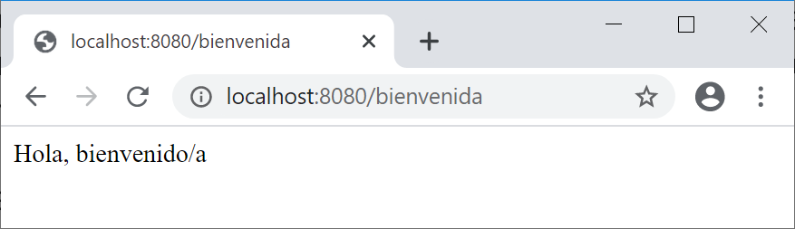
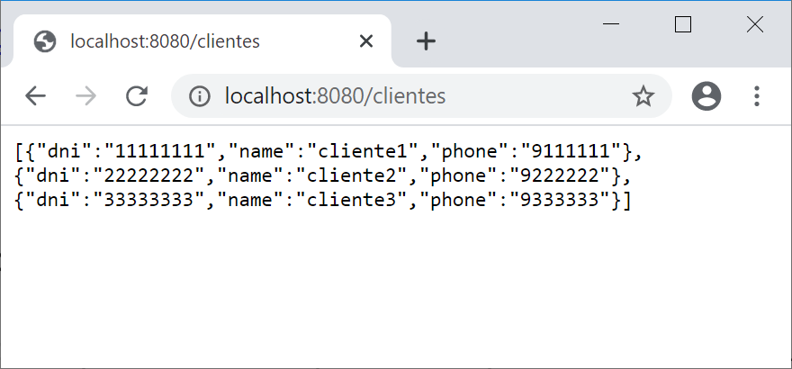
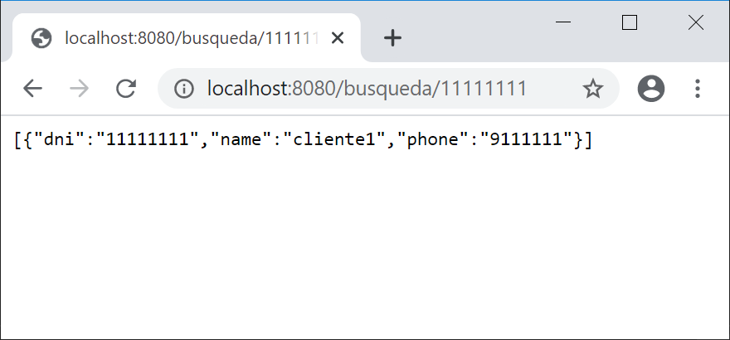
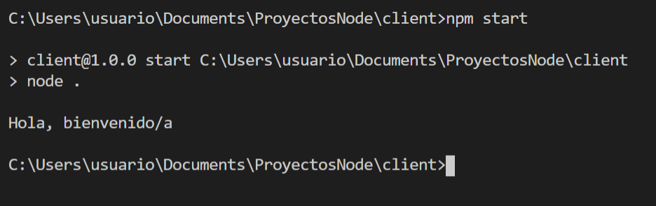
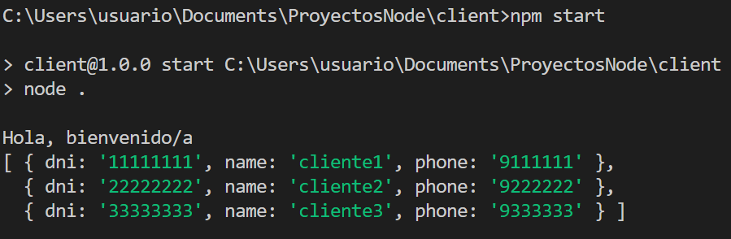
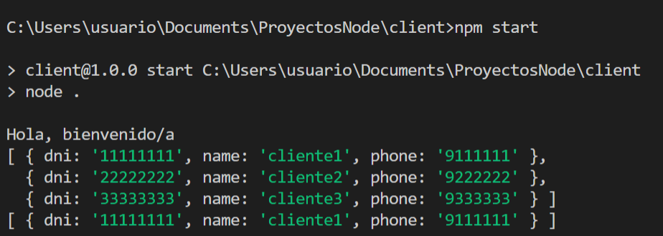
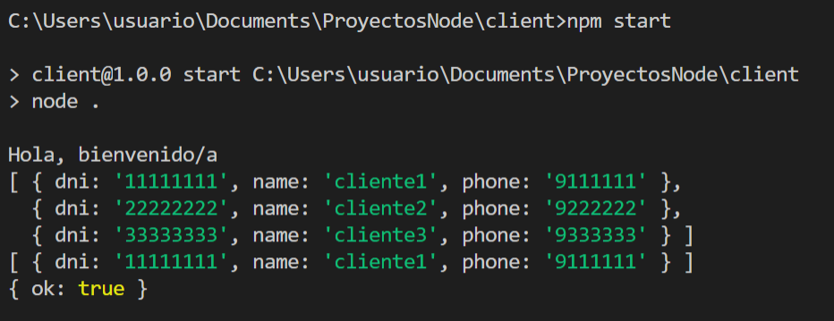
Index.

- Creating a minimal server with Express.
- REST services.
- Clients.json.
- GET: Sending of all content.
- GET: Search by a field.
- PUT: Insert a new customer.
- Name of the routes.
- Apps that make http requests.
- Exercise.

Express is a framework for node that makes it easy for us to create web servers and microservices with node. In this introduction we will look at the most basic parts of express as studying it in depth is beyond the intent of this module. Specifically, we will use express to generate REST services.

1. Creating a minimal server with Express.

To create a minimal server we are going to create a folder called restexpress, inside this folder:

- Create empty index.js file for now.
- Generate the package.json with npm init
- Add the script "start": "node index.js".
- Install express in this app: npm install express.

We are now in a position to create a basic server with express, we are going to write in index.js:

const express=require('express');

let app=express();// we load express

// we define a path: http: // localhost: 8080 / welcome
// and a response to that route: message "Hello, welcome"
app.get('/welcome', (req,res)=>{
res.send('Hello, welcome');
});
// we start the service on port 8080
app.listen(8080);

app.get, is a callback that will be executed when a request is received (when a browser or program makes a request to this url:http: // localhost: 8080 / welcome).
As you can see, the get method has two parameters: the object that contains the request (typically called req, short for request), and the object to emit the response (typically called res, short for response). Later we will see what other things we can do with these objects, but for now we will use the response to send (send) text to the client that requested the service.

app.listen starts listening on the established port for http requests.

If you try to run the application, you will see that it does not finish. We have created a small Express server that awaits requests from clients. The easiest way to test it is to type the following path in a browser:

http: // localhost: 8080 / welcome

2. REST services.

We will try to develop a simple server that provides a REST API to connecting clients. REST stands for REpresentational State Transfer, and designates a style of architecture for distributed applications, such as web applications. In a REST system, we identify each resource to request with a URI (uniform resource identifier), and we define a delimited set of commands or methods to perform:

- GET: to obtain results of some kind (complete listings or filtered by some condition)
- POST: to make inserts or add elements to a dataset
- PUT: to make modifications or updates to the data set
- DELETE: to delete the data set

Therefore, by identifying the resource to request and the command to apply it, the server that offers this REST API provides a response to that request. This response is typically given by a message in JSON format. We will see how we can identify the different types of commands of our API, and the URIs of the resources to request, and then give a response in JSON format to each request.

3. Clientes.json.

As the answer we want to give is in json format, we will use a file that we already used in topic 4:

[
{
"dni": "11111111",
"name": "cliente1",
"phone": "9111111"
},
{
"dni": "22222222",
"name": "cliente2",
"phone": "9222222"
},
{
"dni": "33333333",
"name": "cliente3",
"phone": "9333333"
}
]

4. GET: Sending of all content.

We are going to create a route to send all the content to clients. But first we are going to install a component (the technical name is middleware) that express will use to process the responses in json format: npm install body-parser.

For it to work with express we must write some lines in index.js:

const express=require('express');
const bodyParser=require('body-parser');
const fs=require('fs');// to access the files

let app=express();
// Body-parser to process JSON data from the body of POST / PUT requests
app.use(bodyParser.json());

// welcome path
app.get('/welcome', (req,res)=>{
res.send('Hello, welcome');
});

Now we will create a route to send the content of the entire file to the clients:

// List service for all
app.get('/customers', (req,res)=>{
// read clients from file
let file=fs.readFileSync('./clientes.json');
let customers=JSON.parse(file);
res.send(customers);
});

If now we start the server and in a browser we will http: // localhost: 8080/clients :

In the previous code we have used the get method of an instance of express. In this method we have two parameters (as mentioned above):
- res (from response). The res object allows us to configure what we send to the requesting client. In this case we send the content of a JSON file.
- req (from request)The req object gives us information about the request made by the client. In this example it is not used, but we will use it in others.

5. GET: Search by a field.

To search for the ID field to obtain a specific ID, we can use the following code:

// ID listing service
app.get('/ search /: dni', (req,res)=>{
// read clients from file
let file=fs.readFileSync('./clientes.json');
let customers=JSON.parse(file);
// search for customer with ID in array customers
let clients=customers.filter(client=>client.DNI==req.params.DNI);

if(clients! =null)
res.send(clients);
else
res.send({
Error message:"No customers with that ID have been found"
});

});

In this case the call to get contains a dni parameter, we will use req.params to access the value of that parameter.

To test this:

6. PUT: Insert a new customer.

To include a route that inserts a new client:

// Service to insert clients
app.post('/ insert', (req,res)=>{
try{
// get the customer given with the request post
let new client=req.body;
// read clients from file
let file=fs.readFileSync('./clientes.json');
let customers=JSON.parse(file);
// add the new customer:
customers.push(new client);
// save the entire file:
fs.writeFileSync('./clientes.json',JSON.stringify(customers));
res.send({okay:true});
}
catch(err) {
res.send({okay:false});
}
});
We assume that the object to insert comes in JSON format and we retrieve it through req.body. We return a true or a false to the program that makes the request so that it knows if it was good or bad.

7. Name of the routes.

During this example we have named the routes like this:

/welcome
/customers
/ search /: dni
/ insert

It has been done to improve the understanding of the express server. These names are perfectly valid but the last three act on the same data set: customers.json. In these cases the same path name is used, express differentiates them by the method with which they are accessed (get, put, post, delete) and by the parameters they carry. Applying this, the complete code of index.js looks better like this:

const express=require('express');
const bodyParser=require('body-parser');
constfs=require('fs');// to access the files

let app=express();
// Body-parser to process JSON data
// from the body of POST / PUT requests
app.use(bodyParser.json());

// welcome path
app.get('/welcome', (req,res)=>{
res.send('Hello, welcome');
});

// List service for all
app.get('/customers', (req,res)=>{
// read clients from file
let file=fs.readFileSync('./clientes.json');
let customers=JSON.parse(file);
res.send(customers);
});

// ID listing service
app.get('/ clients /: dni', (req,res)=>{
// read clients from file
let file=fs.readFileSync('./clientes.json');
let customers=JSON.parse(file);
// search for customer with ID in array customers
let clients=customers.filter(client=>client.DNI==req.params.DNI);

if(clients! =null)
res.send(clients);
else
res.send({
Error message:"No customers with that ID have been found"
});

});

// Service to insert clients
app.post('/customers', (req,res)=>{
try{
// get the customer given with the request post
let new client=req.body;
// read clients from file
let file=fs.readFileSync('./clientes.json');
let customers=JSON.parse(file);
// add the new customer:
customers.push(new client);
// save the entire file:
fs.writeFileSync('./clientes.json',JSON.stringify(customers));
res.send({okay:true});
}
catch(err) {
res.send({okay:false});
}
});

app.listen(8080);

8. Apps that make http requests.

In point 1 of this topic we saw how node incorporates a module to make http requests. There are several modules that can be installed with rpm that facilitate this task. Specifically now we are going to use node-fetch (which gives the same functionality as fetch in browsers). We create a client project where node-fetch will be used to test the routes that we made in the restexpress project made above:

- Create a folder called client, inside an empty app.js file.
- With npm init the package.json is generated, where we add the script "start": "node ."
- We install node-fetch, from the client folder: npm install node-fetch.
Now in app.js we will make requests.

Test the route / welcome

const fetch=require('node-fetch');
const resource="http://127.0.0.1:8080";

// Get for welcome:
fetch(resource+'/welcome')
.then(res=>res.text())
.then(body=>console.log(body));

With fetch the asynchronous request of the resource is performed. Two .then promises are chained to this, one for res (from response) to obtain the data and another with body to use the returned data.
If we execute this project (before we must have in execution that it provides the services and that we call restexpress):

Test the path / clients.

In this case we must obtain a json file:

// Get for all clients:
fetch(resource+'/customers')
.then(res=>res.json())
.then(json=>console.log(json));

Therefore in the first then we use the json method of res.
If we execute:

Test the route / clients: dni

// Get to search by ID:
let DNI="11111111";
fetch(resource+'/customers/'+DNI)
.then(res=>res.json())
.then(json=>console.log(json));

Test the post / clients route.

// new object with the appropriate format:
let new= {
"dni":"72345672",
"yam":"client",
"phone":"9111111"
};
// post insert client
fetch(resource+'/customers', {
method:'post',
body:JSON.stringify(new),
headers:{'Content-Type':'application / json'},
})
.then(res=>res.json())
.then(json=>console.log(json));

Also, in this case, we can check that a new record has been inserted in the clients.json file.

9. Exercise.

1. Define a basic server that responds by GET to these two URIs:

/date: The server will send the current date and time as a response to the client. You can just use the Javascript Standard Date type:

https://developer.mozilla.org/es/docs/Web/JavaScript/Referencia/Objetos_globales/Date

Or you can also use the "moment" library, installing npm install moment:

https://momentjs.com/

/user: the server will send the login of the user who entered the system. You will need to use the "os" library from the Node core:

https://nodejs.org/api/os.html

2. Create a client to test those routes.

